**DWB Assignment**

PBWEBe2023

Ionut Gabriel Salgau

Link to the website: https://demo.webriel.ro/Mcvshop/

Keystrokes:

**INTRODUCTION**

The mcvshop project stands as a dynamic e-commerce platform developed using PHP, Bootstrap, CSS3. Founded upon an initial design prototype conceptualized within Adobe XD, this webpage showcases a robust responsiveness across diverse devices, ensuring seamless user experiences.

The development process adhered closely to the prototype, resulting in a fully functional web page where every link operates as intended. This report aims to explore the mcvshop website, breaking down its design, functions, and how it handles security, user sessions, and its overall architecture. My goal is to provide a clear understanding of how this online store is set up and how it keeps everything running smoothly.

**DESCRIPTION OF THE WEBPAGE IN GENERAL**

The mcvshop website serves as a functional e-commerce platform designed to fulfill the requirements outlined in the DWB assignment. The inception of this project involved the creation of an Adobe XD prototype, establishing the groundwork for a well-structured web page. Emphasizing the principles of responsive design, particular attention was given to aligning elements across various screen sizes, ensuring a modern and adaptable user interface.

Additionally, the focus was on the code, utilizing all the techniques taught in classes and implementing a robust structure using PHP and SQL.

For SQL, a comprehensive set of techniques learned in class were employed, encompassing Database Design, ER Modeling, Sketching the DWP Database, ER to RDM Conversion, Normalization, as well as SQL Implementation and Security measures.

In terms of PHP, the development centered on crucial functionalities such as Database Connection, Login Sessions, Basic Object-Oriented Programming (OOP) principles, and integrating essential security measures.

However, despite the approach to implementation, challenges emerged during development, hindering the successful integration of certain functionalities outlined in the assignment. These unimplemented functions and encountered challenges will be addressed further in this report.

**DESCRIPTION OF THE FUNCTIONS CONTAINED IN THE WEBPAGE**

The following functions and features were implemented in the webpage:

1. A fully functional contact form which sends email to the owner of the webshop - The contact form lets visitors send emails to the website owner. It uses PHPMailer to securely send messages. Users fill in their name, email, and message, and the form ensures a safe way to send these details through an email. Behind the scenes, the code sets up how the email is sent securely, managing the sender's and recipient's information. If the email goes through successfully, it confirms to the user. If there are any issues, it shows an appropriate message.

2. Products page with Database-loaded products variations - The products page displays a range of products fetched from Mcvshop database. Each product showcases various details like its image, name, price, and an option to add it to the cart. This functionality is achieved by connecting to the database and retrieving product information dynamically. Using PHP and MySQL, the code fetches product data from the database and showcases it on the webpage.

3. Shopping cart - The shopping cart feature allows users to add and manage products for potential purchase. It operates independently of the database, functioning as a basic cart that temporarily stores added items during a user's session. Upon selecting a product, it is added to the session-based cart, enabling users to view the added items.

Each product within the cart displays essential details like its image, name, price, and quantity. Users can easily remove items from their cart using the "Remove" option associated with each product.

The code dynamically fetches product details from the database and showcases them in the cart for user interaction. However, it's essential to note that this cart feature doesn't store data permanently in the database. It solely manages items within the user's session for the duration of their visit. While the checkout functionality isn't available due to encountered errors in setting up the Stripe payment system, this shopping cart serves as a functional tool for users to add, review, and remove items during their browsing session.

4. A recommendation system for products – The recommendation system showcases a selection of recommended products to users on the webpage. This functionality operates by pulling specific products from the database marked as "recommended" using a newly added column called IsRecommended. To implement this feature, a modification was made in the database schema by adding a column IsRecommended to the Product table. This column allows the system to differentiate and fetch products marked as recommended.

5. A news section - The news section displays articles fetched from the database, providing users with updates or articles related to the e-commerce platform. This functionality is implemented using PHP to retrieve and showcase news articles stored in the database. The code connects to the database and retrieves news articles sorted by their posting date in descending order (ORDER BY DatePosted DESC). For each news article found in the database, the system generates a card displaying the article's title, content, and an associated image.

Additionally, the main page includes a section displaying recommended news articles. This limited section exhibits up to three latest news articles marked as recommended in the database using the same method by adding a column IsLatest to the News table in the mysql.

6. Login and Registration System - The website integrates a user login and registration system. User data, including usernames, passwords (hashed for security), emails, and additional details such as names, addresses, and contact numbers, are stored in the database. The registration form collects required user information and facilitates new user sign-ups. Likewise, the login form allows registered users to securely log into their accounts. Following this, a option to logout your session is implemented in the navbar after you login.

Back-End Functions and Security Measures: During the development process, I focused on establishing a 3NF database structure to ensure efficient data organization and minimize redundancy across tables. To fortify the database against SQL injection attacks, I implemented robust security measures. Additionally, I prioritized user data protection by employing secure password hashing techniques, converting plain text passwords into complex, irreversible strings.

Development Challenges and Admin Panel Limitations: Embarking on this project, I faced significant developmental challenges, particularly in PHP and SQL, having come from a multimedia design background with minimal knowledge in these areas. However, throughout the project, my PHP skills underwent a remarkable improvement, especially in implementing database-related functionalities. Given the complexity of the project and the learning curve involved in transitioning from a design-centric background to mastering PHP and SQL, the admin panel's despite these efforts, functionality remains limited, largely offering login and logout actions due to the complexities encountered during development.

**APPENDIX1. PERSONA JAMES**

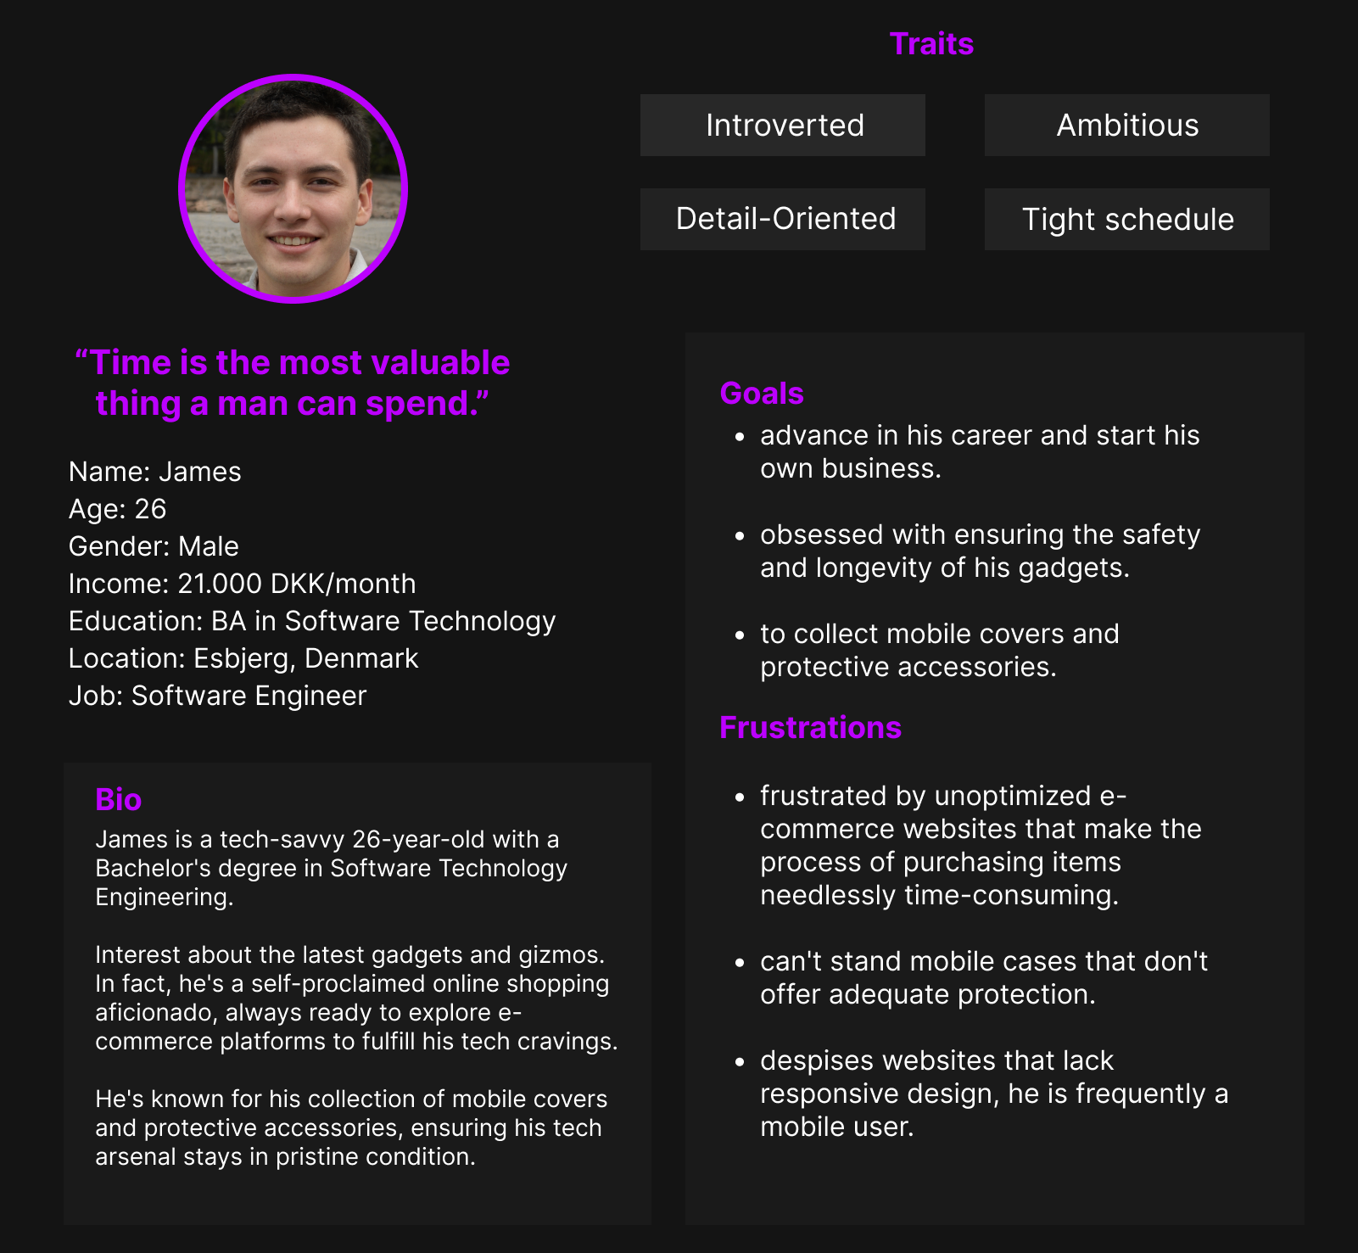

**APPENDIX2. UX ELEMENT MOODBOARD**

**APPENDIX3. WEBSITE ADOBE XD PROTOTYPE (UX ELEMENT)**

